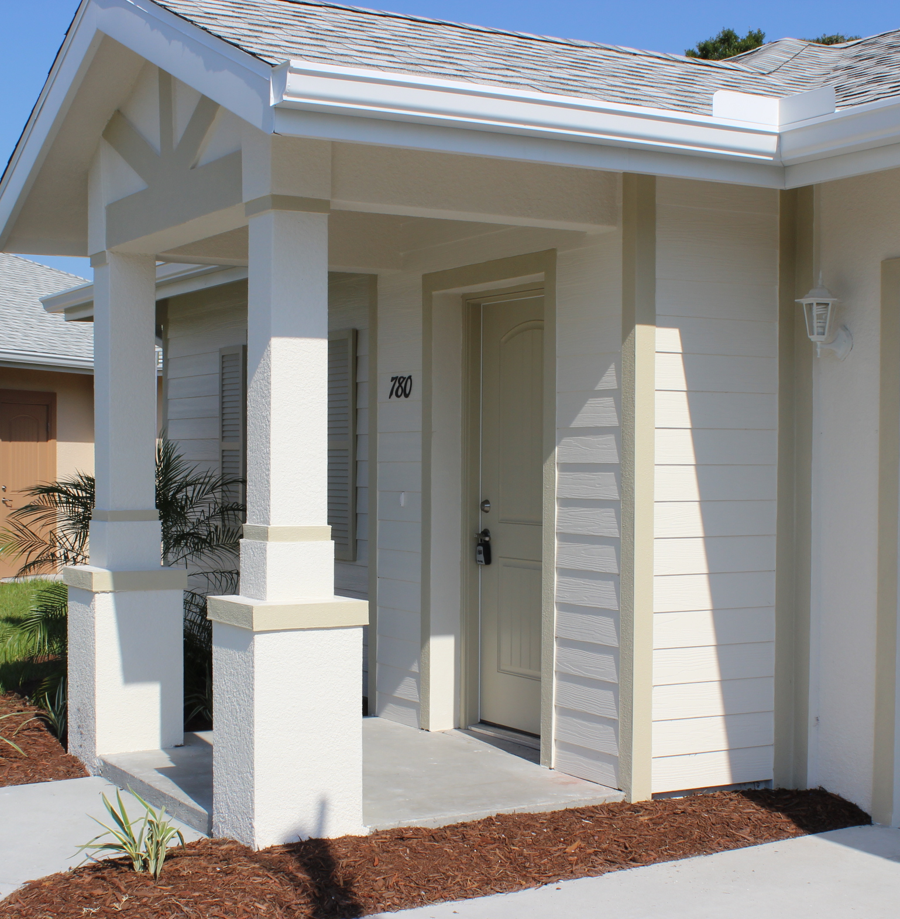
Building America Case Study

Title of Case Study Here
[Arial Bold 23 pt]
City, State of house or development [Arial 15pt]


Use journalism style: Lead with something significant about the project (first home constructed by a production builder to achieve this level of efficiency, lower HERS rates, demonstrated significant energy savings, won awards, improved sales, improved health and safety, etc.) In the first paragraph, answer the who, what, when, where, and why. Note the purpose of the project (was it a custom, production, multifamily, affordable? Was it a prototype for the builder?). Identify the Building America teams involved and their role. The first paragraph should answer the question: why does the research matter? [Times New Roman 11pt]
_________________________
PROJECT INFORMATION
[Arial Bold 12pt]
Construction: New Home
Type: Single-family, affordable
Builder: Habitat for Humanity of Palm Beach County, Florida
www.habitatpbc.org
Size: 950 to 1,340 ft²
Price Range: about $90,000
Date completed: 2011
Climate Zone: Hot-humid
Team: CARB
_________________________
PERFORMANCE DATA
HERS index: with PV 3, without PV 47
Projected annual energy cost savings: $434
Added cost of energy-efficiency measures: $1,500
Annual mortgage payment increase: $75
Annual cash flow to homeowner: $359
Billing data: $___ /yr]

In the second paragraph, provide project context (business setting, market conditions, special climate considerations, etc.). Provide more details on the project (description of the homes, unique architectural features, size of the development, description of technologies used, etc.) What insulation, air sealing, and moisture management was used for the foundation, walls, attic, and roof? What HVAC, water heating, lighting, and appliances were installed?

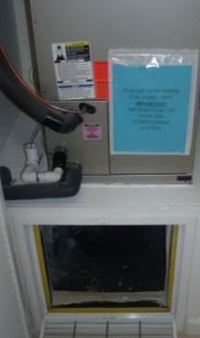

Photos/Captions: Use high-resolution JPEG photos of the project. Include both finished house shots and shots that show specific measures. Readers usually look at photos and captions first; use the captions to tell your research story. At least one caption should tell the builder’s name, place, overall value of the project. Another caption can highlight a significant finding. For example, caption 1 -Tommy Williams Homes moved ducts inside the building envelope on all house plans to achieve average HERS scores of 56 on its 1,500 to 2,000-ft² homes in Gainesville, Florida. Caption 2 – Artistic Homes employs advanced framing techniques like 2-stud corners and open headers, which use less lumber and provide more space for R-21 blown cellulose in its 2x6 24-inch on-center framed walls. [Arial 9pt]

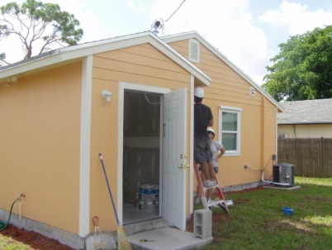
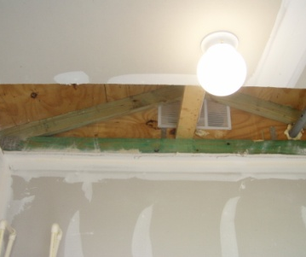
KEY ENERGY-EFFICIENCY MEASURES [Arial Bold 12pt]
____________________________
HVAC [Arial Bold 11pt]
• SEER 14 AC with strip heat (little heating load in south Florida)
• Mastic-sealed R-6 flex ducts in vented attic. Air handler in interior closet. Return air jump ducts in all bedrooms. Duct leakage to outside
= 26 cfm @ 25 Pa
• Positive pressure whole-house ventilation system (run-time only)
• Kitchen and bath fans vented to outside
____________________________
Envelope
• Light colored shingle roof, hip-roof
• R-38 blown fiberglass on ceiling deck, vented attic
• R-13 grade-1 batt insulation in
2x4 frame wall, R-5 XPS rigid foam sheathing with taped seams, furring strips, fiber cement siding
• uninsulated slab-on-grade foundation
• Double-pane, low-e, vinyl-framed windows. U=0.34, SHGC=0.26
• ACH50 = 2.5 _______________________________
Lighting, Appliances,
and Water Heating
• 100% CFL
• ENERGY STAR® ceiling fans
• ENERGY STAR® refrigerator
• Heat pump water heater
[Arial 10pt]
____________________________
For more Information, please see:
Authors. Year. Title of report, organization. url ____

All images courtesy of CARB.

See note on previous page about captions. Make the captions full sentences.

Include a third paragraph if space allows, describing technologies used and project outcomes (completed, occupied, received awards, received incentives, sales data, utility data, or other measured data, etc.)

Include a fourth paragraph if space allows, with more project outcomes.

Lessons Learned [Arial 18pt]

This should be a bulleted list; include items such as:
- Technical issues implementing measures or practices
- Actual energy savings compared to predicted savings
- How actual material and installation costs compare to expected learning curve mature costs
- Performance issues associated with measures or practices
- Code issues implementing measures or practices
- Business metrics including time of construction, customer satisfaction, call backs, time for sale, and marketing expenses
- What would be done differently based on experience.
[Times New Roman 11pt]

“If you have room, quote the builder telling the significance of the research project.” [Arial 12pt]

Person’s name, title
Company or organization [Arial 9pt]

