
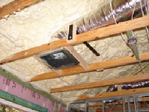
Building America Case Study

Ducts Inside Conditioned Space [Arial Bold 23 pt]
City, State

____________________________
PROJECT INFORMATION [Arial bold 11 pt]
Project Name: [Arial plain 10pt]
Location: City, ST
Partners: Builder company name, url
Building America partner team name, url
Building Component: Building envelope component, HVAC, lighting, or water heating
Application: New and/or retrofit; Single and/or multi-family
Year Tested: 20XX
Applicable Climate Zone(s): all or specify which ones
____________________________
PERFORMANCE DATA [of the measure alone, not whole house]
Cost of Energy-Efficiency Measure (including labor): $X,XXX
Projected Energy Savings: XX% heating, cooling, or overall savings
Projected Energy Cost Savings: $XX/month or $XXX/year



[Times Roman 11 pt] In the first paragraph, state the context for the measure. (For example, “Ducts are commonly located in unconditioned attics, crawl spaces, and basements where they experience up to ten times more conductive losses than ducts located in conditioned space. Studies indicate leaking ducts can account for heating or cooling losses of up to 30% to unconditioned spaces.”)

Explain what the measure is. Describe how it works. Mention any building science issue(s) addressed (air flow, thermal flow, moisture flow are better controlled). Note the benefits of the measure (e.g., higher efficiency, improved comfort or health, less call-backs, more useable space).

(For example, “Habitat for Humanity of Palm Beach, Florida, worked with Building America to determine the most effective way to incorporate heating and cooling ducts within the thermal boundary of its homes. Ducts had been located in vented, unconditioned attics. The Building America partner, the Industrialized Housing Partnership, recommended sealing and insulating the attics along the roof line with spray foam insulation to provide a conditioned space for the ducts and the high-efficiency heat pumps. A ducted fresh air intake brings fresh air into the return side of the air handler. Moving the ducts and air handler into conditioned space greatly reduced conduction losses for the ducts and lessened concerns about duct leaks. Ducts were still insulated and sealed with mastic at joints to improve distribution efficiency.”)

“You can include a quote from the builder specific to this measure if there is room.” [Arial 12 pt]
Joe Q Builder,
Title, company [Arial 10 pt italic]

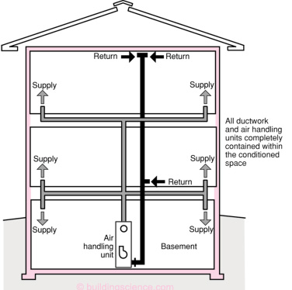 | [Arial 10 pt, gray] If you have room, include one or two larger drawings and/or photos at the top of this column showing the measure with captions placed under or to the side of the images. Caption example: For optimal performance and energy savings, the heating and cooling equipment and ducts should be located within the conditioned space of the home, indicated on this drawing by the pink line.

Add another paragraph of text here talking about project results if there is room.
DESCRIPTION [Arial bold 11 pt]
[Arial 10 pt, gray] Put drawings and/or photos showing how this measure is used, with captions that describe how it is used. This could be 1-4 sequential numbered images with a numbered descriptive caption, or 1-3 individual photos and captions.

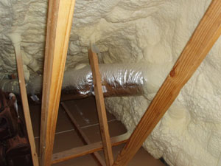
Habitat for Humanity of Palm Beach locates its HVAC equipment and ducts inside conditioned space in the attic, which is insulated along the roofline with three inches of closed-cell foam.

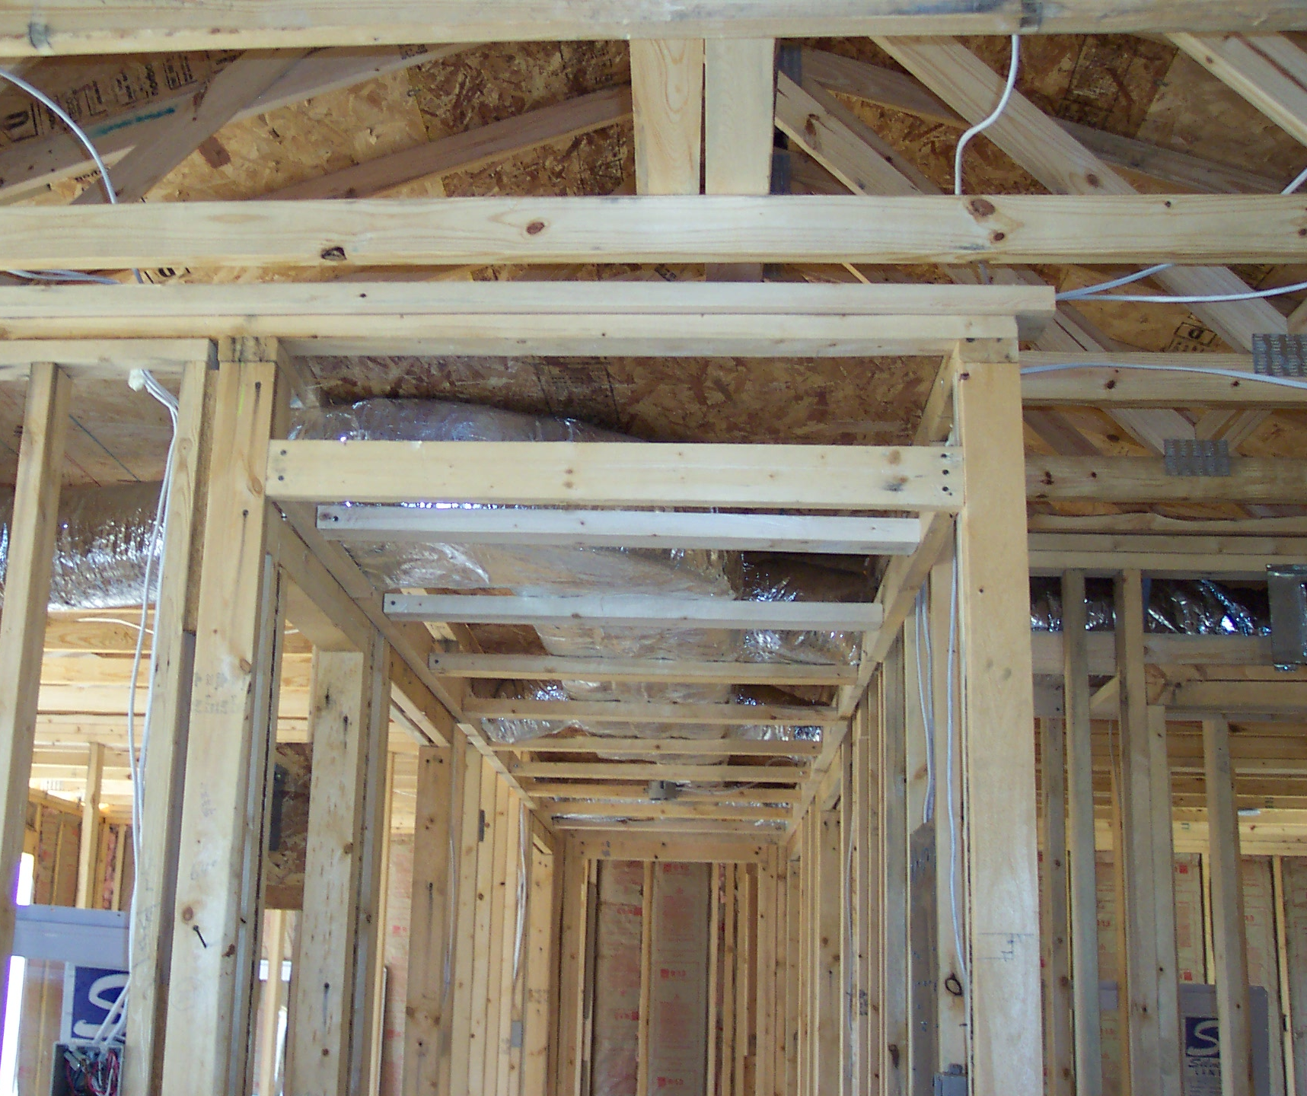
Some builders locate the furnace in a utility closet within the home and use a compact duct design with a main trunk located in conditioned space in a dropped ceiling chase in the hallway.
____________________________
For more Information, see
Authors. Year. Title of report, organization. url….

Images courtesy of team name.

Lessons Learned [Arial 16 pt]
- [Times Roman 11 pt] Include a bullet list, including any or all of the following, not necessarily in this order. Ok if there is some repeat from first page.
- Challenges (technical challenges, not personnel challenges)
- Results (can flesh out data in sidebar on first page here)
- Benefits (modeled and/or actual)
- Comparisons with alternate options
- Costs (implementation costs)
- What would the builder do differently?

Looking Ahead [Arial 16 pt]
[Times Roman 11 pt] Include a few sentences describing future plans for this technology, future research needs, or anticipated changes, either in production, implementation, or costs. For example, will costs decrease due to economies of scale as the technology goes into production mode? Is the builder planning to implement this in all future projects? Will this soon be required by code? This section can go in the sidebar on this page, if necessary for spacing.

